**Capstone project**

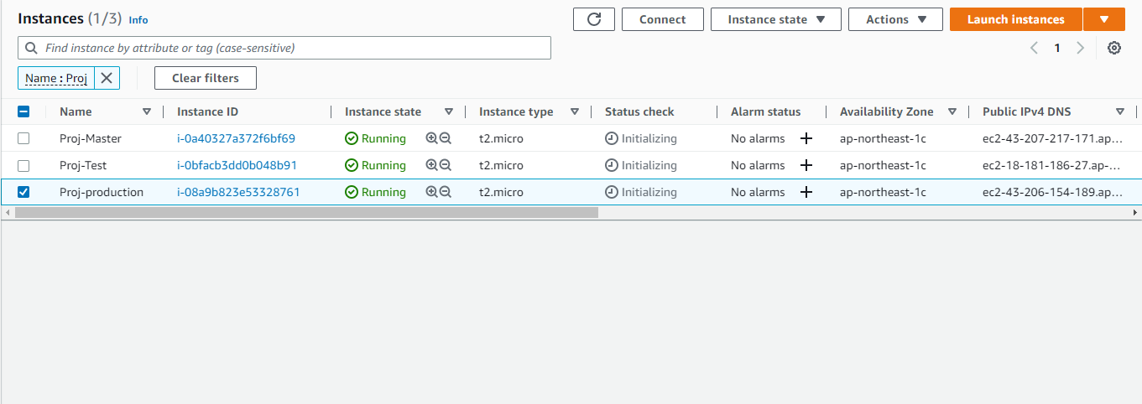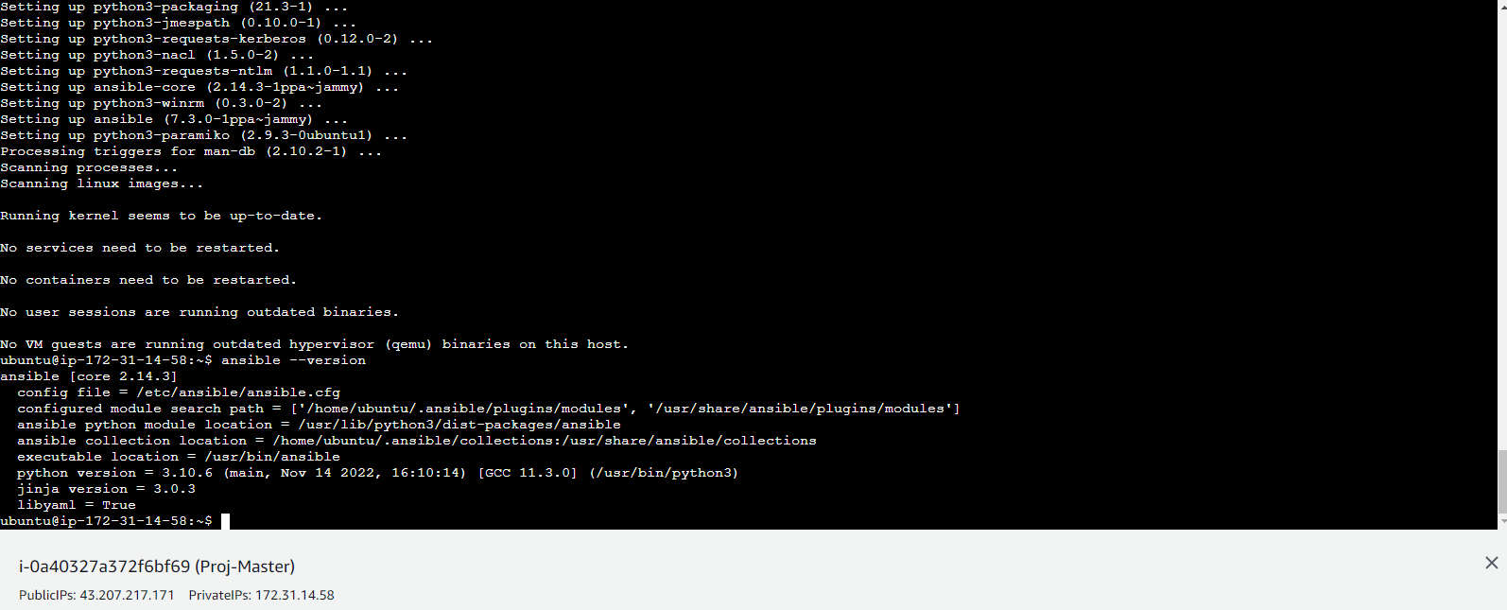

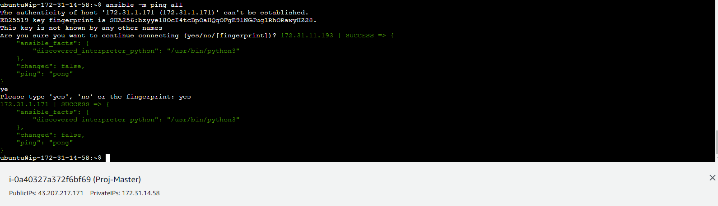

Slave.sh

sudo apt install openjdk-11-jdk -y

sudo apt install docker.io -y

Master.sh

sudo apt install openjdk-11-jdk -y

sudo apt install docker.io -y

curl -fsSL https://pkg.jenkins.io/debian-stable/jenkins.io.key | sudo tee \

/usr/share/keyrings/jenkins-keyring.asc > /dev/null

echo deb [signed-by=/usr/share/keyrings/jenkins-keyring.asc] \

https://pkg.jenkins.io/debian-stable binary/ | sudo tee \

/etc/apt/sources.list.d/jenkins.list > /dev/null

sudo apt-get update

sudo apt-get install jenkins -y

Playbook.yaml

---

- name: installing java,jenkins and docker

hosts: localhost

become: true

tasks:

- name: executing master.sh

script: master.sh

- name: installing java and docker

hosts: slaves

become: true

tasks:

- name: executing slave.sh

script: slave.sh

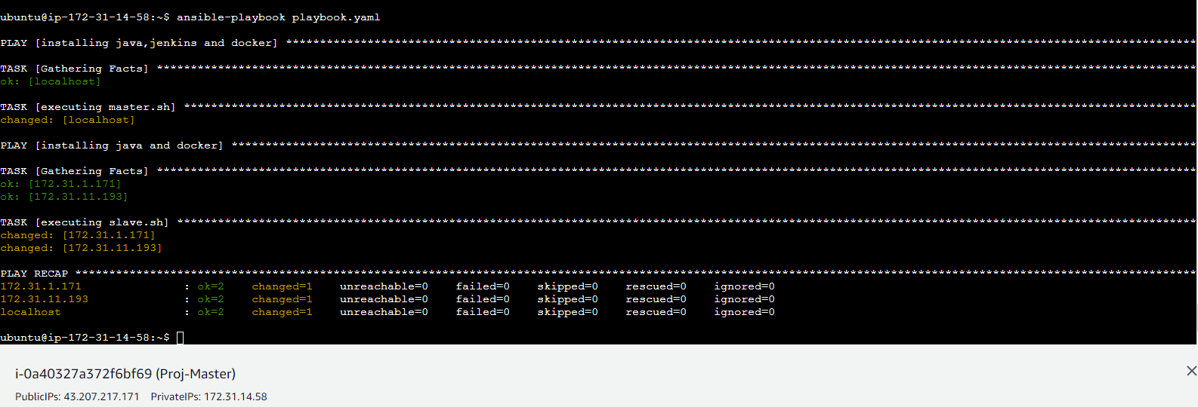

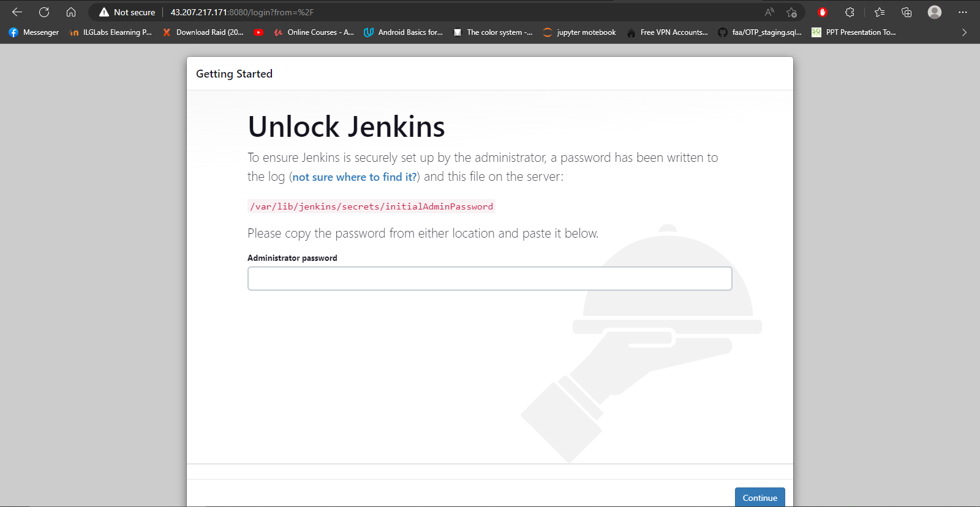

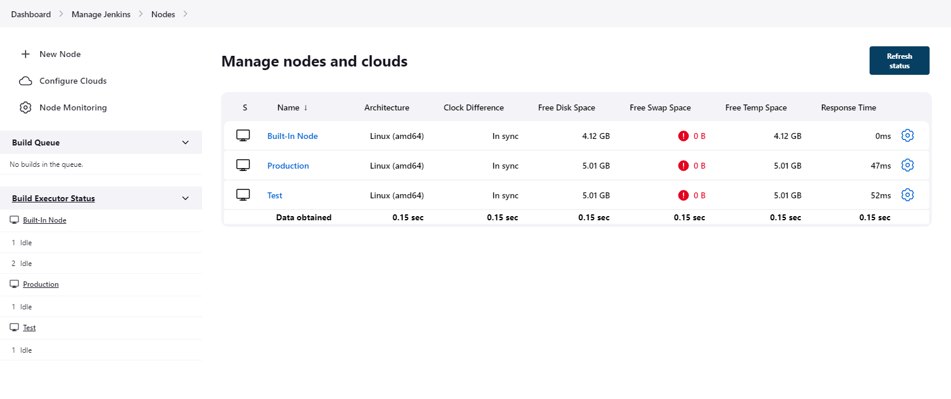

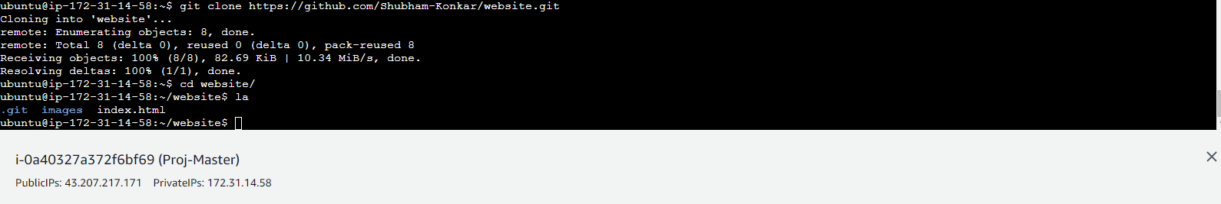

Create ssh connection with Github account

origin https://github.com/Shubham-Konkar/website.git (fetch)

origin https://github.com/Shubham-Konkar/website.git (push)

origin1 git@github.com:Shubham-Konkar/website.git (fetch)

origin1 git@github.com:Shubham-Konkar/website.git (push

Create a Dockerfile

FROM ubuntu

RUN apt update

RUN apt install apache2 -y

ADD . /var/www/html

ENTRYPOINT apachectl -D FOREGROUND

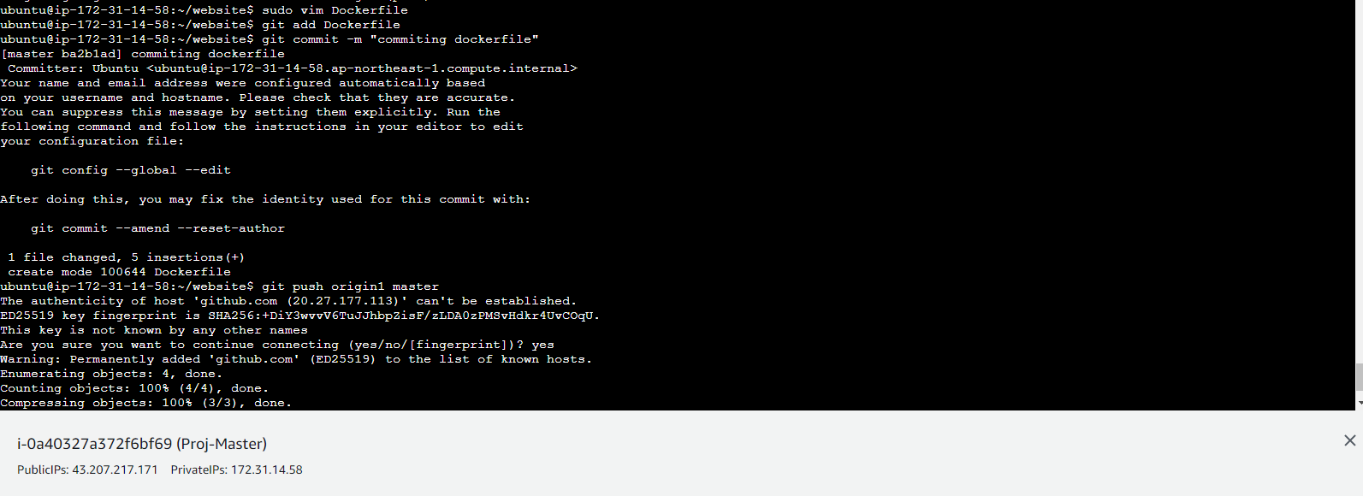

Next we create develop branch and push it in Github

Next we create

job1 -> Develop branch on test server

job2 -> Master branch on test server

job3 -> Master ranch on test server [ will be connected with job2]

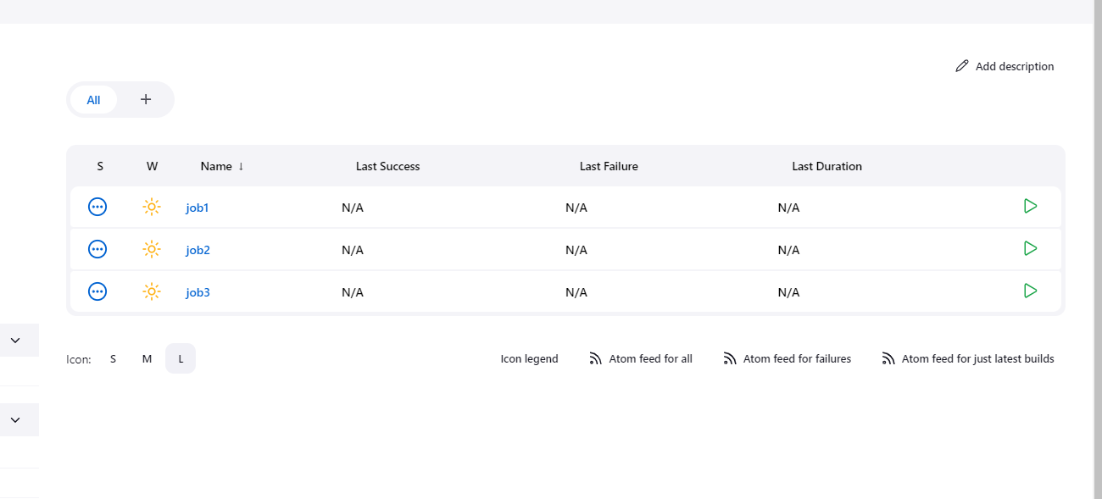

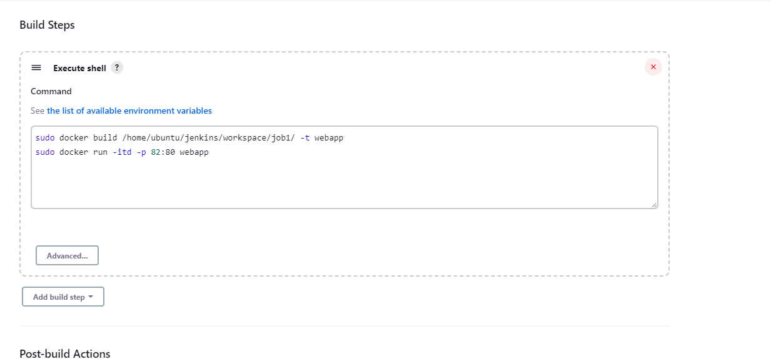

After doing build now in job 1

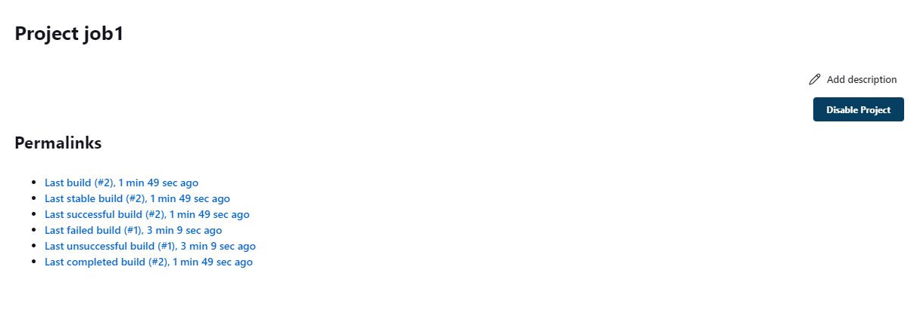

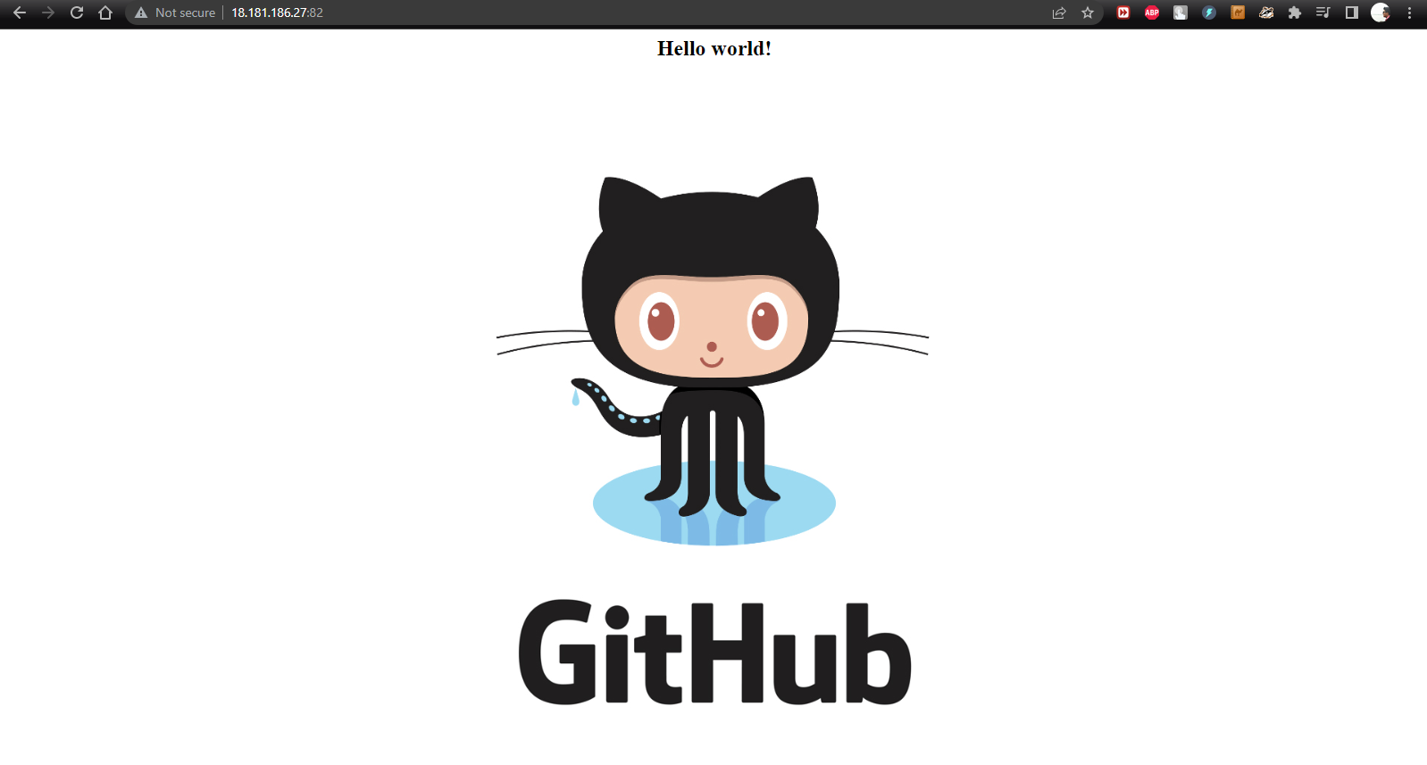

Now we have to run job2

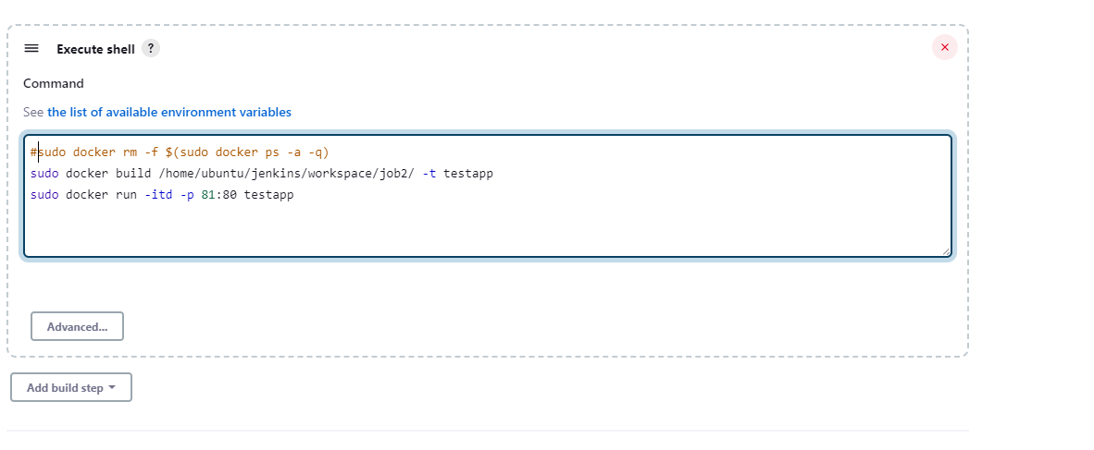

After doing build now in job 2

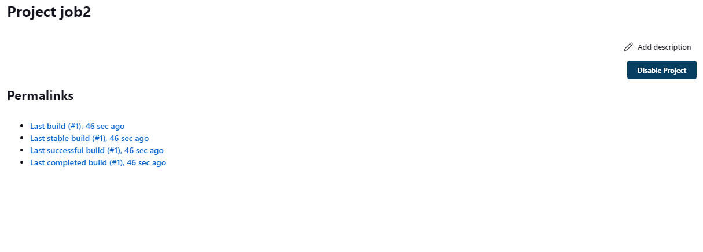

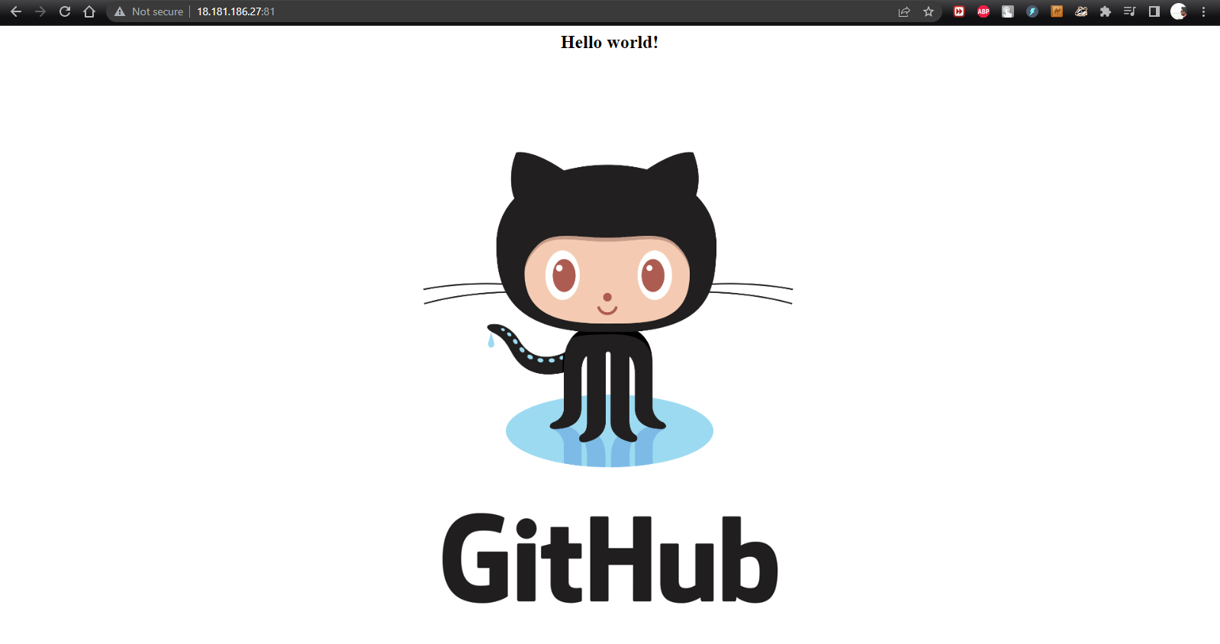

Now we have to run job3

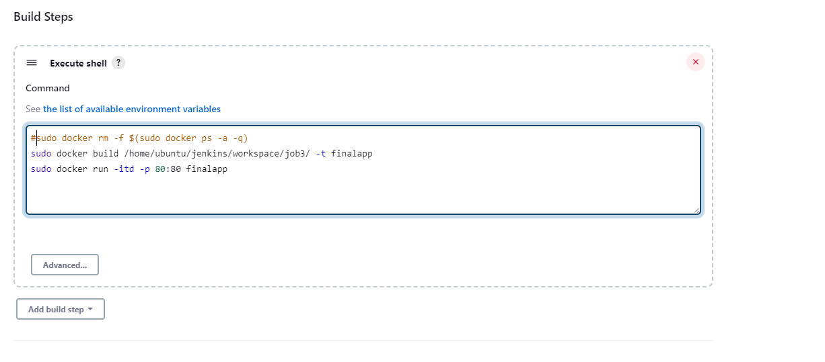

After doing build now in job3

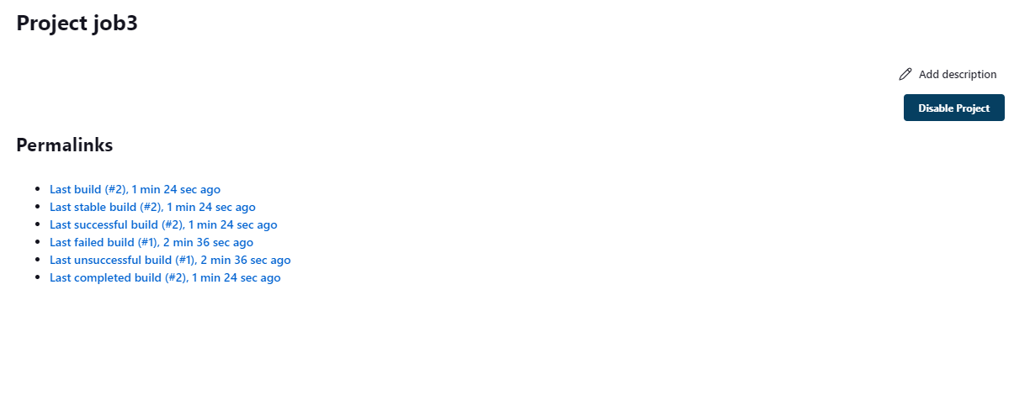

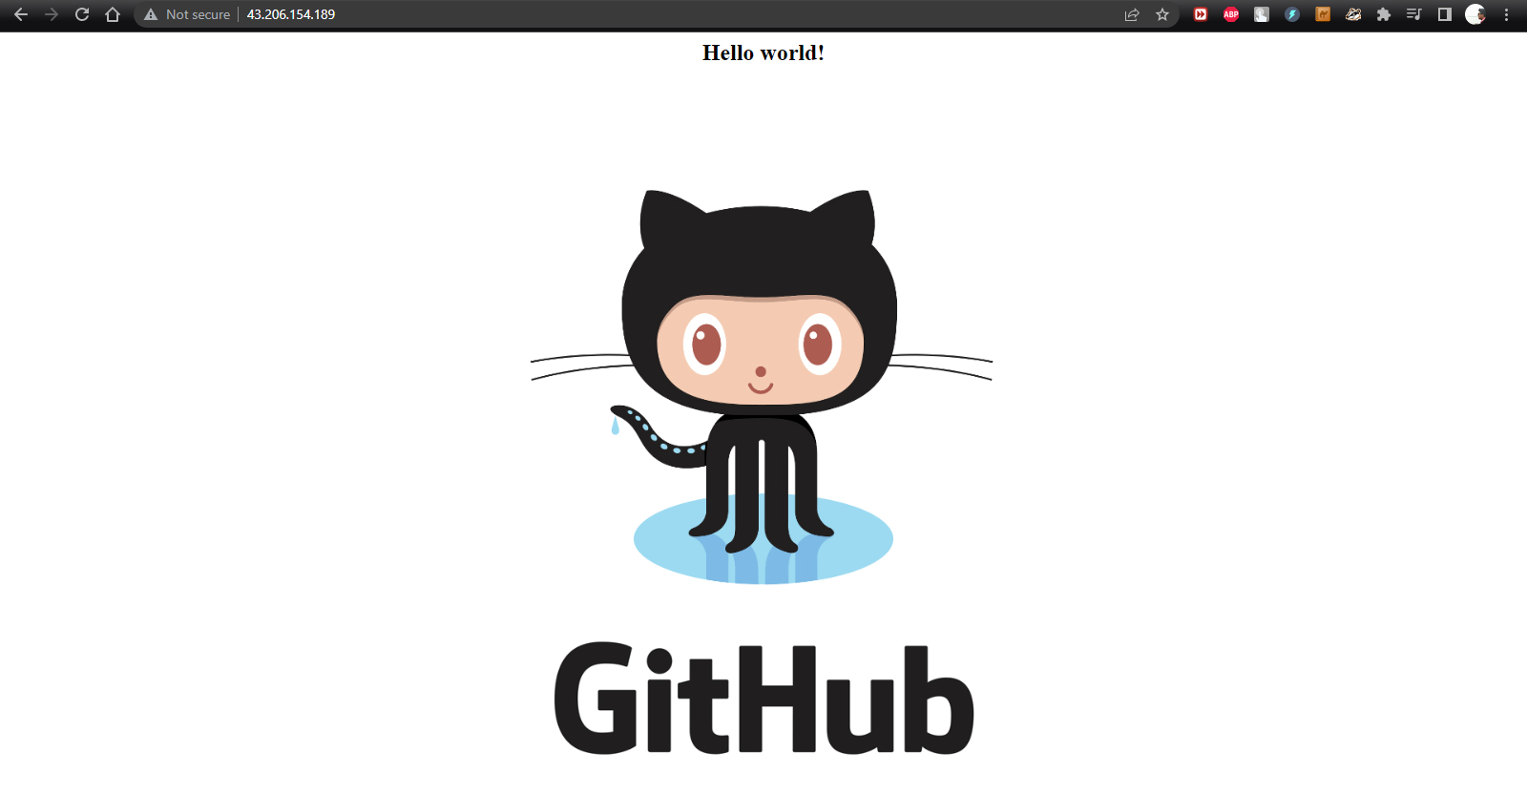

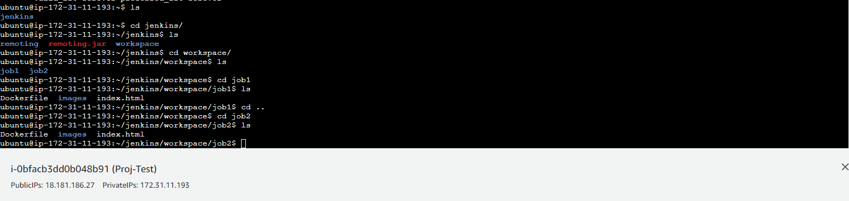

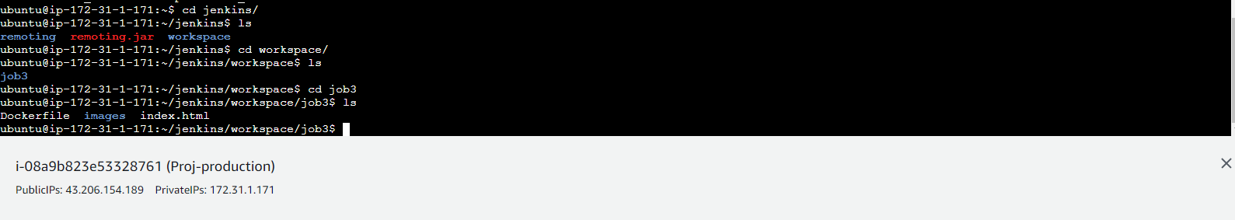

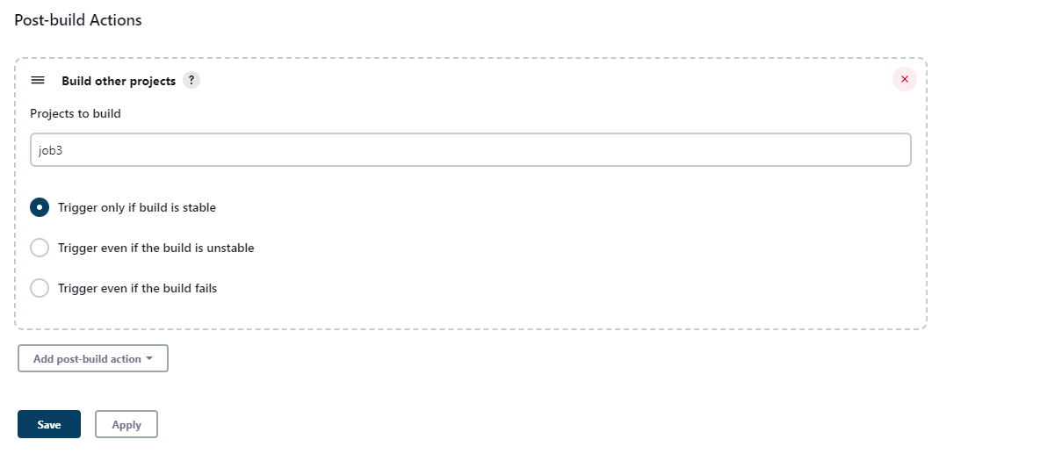

Now whenever we run job2, job3 will run automatically

